Intensive Part-Writing and Analysis

W.A. Mozart, Piano Concerto in A Major, K. 488, I

Primary Themes

P Theme – 1st Violin, ms. 1-8

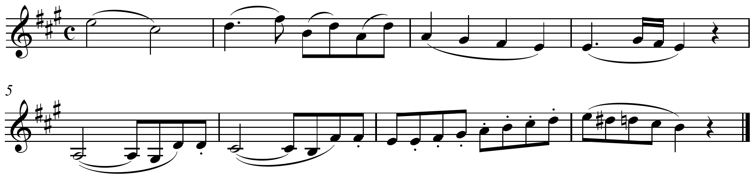

T Theme – 1st Violin, ms. 19-22

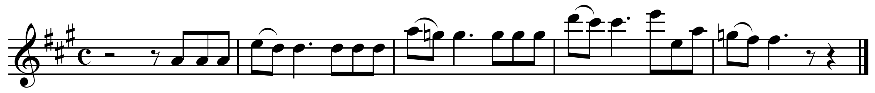

S Theme – 1st violin, ms. 31-38

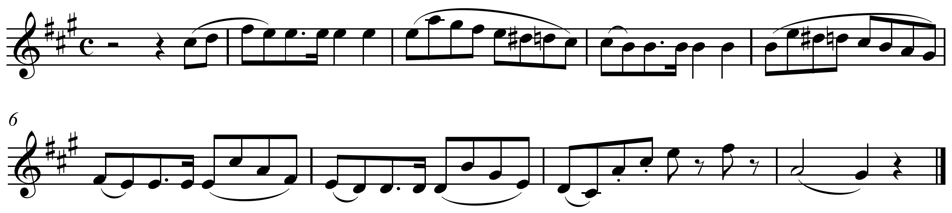

K Theme – 1st Violin, ms. 47-52

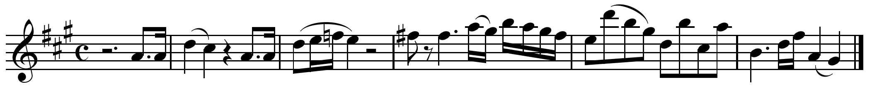

D Theme – 1st violin, ms. 143-149

