Intensive Partwriting and Analysis

Schubert Sonata for Violin and Piano, Op. Posth. 162, D. 574, IV

Structure and Primary Themes

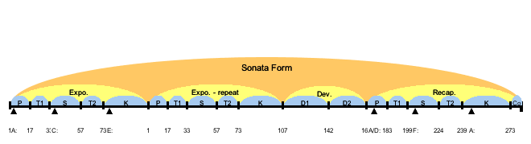

P Theme

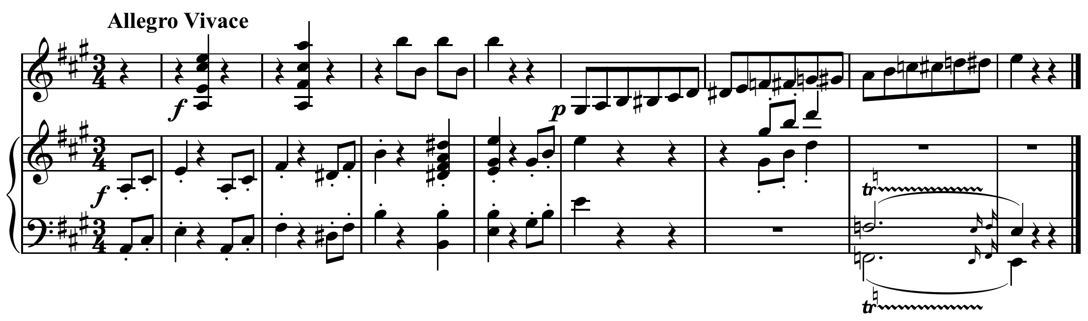

S Theme

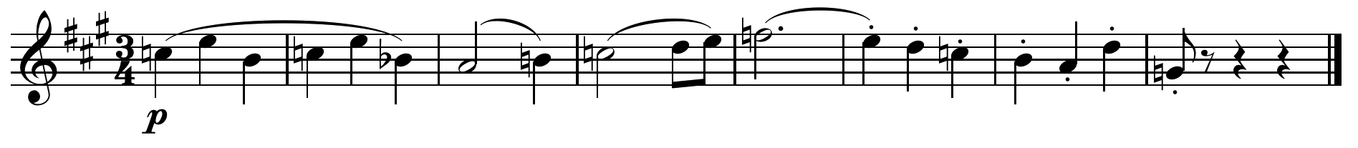

K Theme

