Intensive Part-Writing and Analysis
Assignment 12 Worksheet

- Using half notes, write and resolve the following secondary dominants. In addition, show the appropriate roman numerals underneath the chords of resolution.

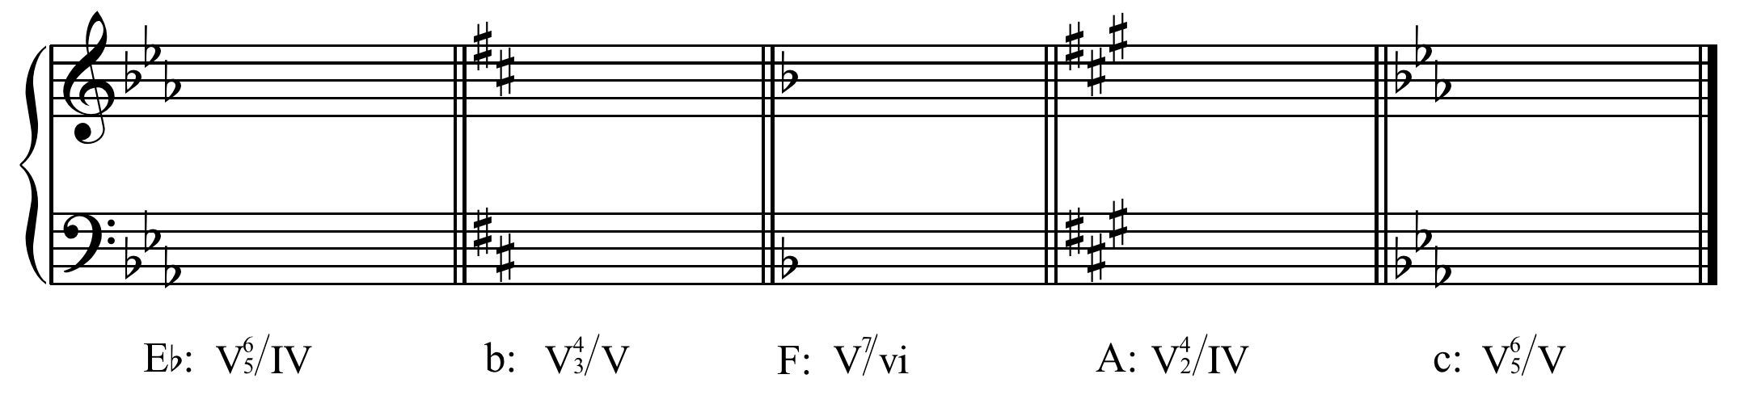

- Realize the following figured bass for SATB. Indicate the key and do a complete Roman Numeral analysis (including inversions) underneath the figures.

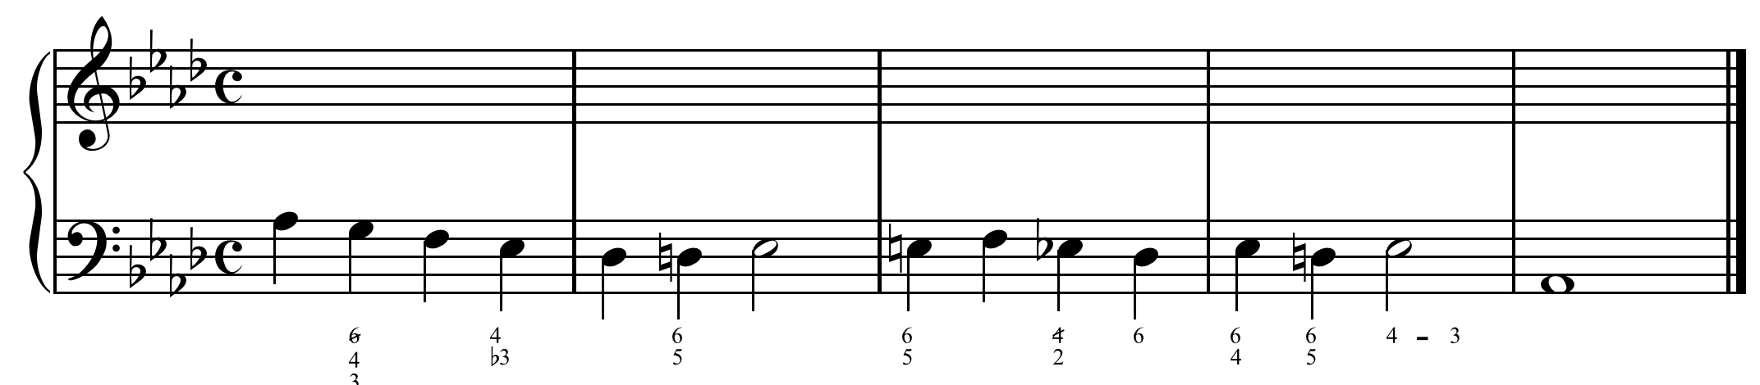

- Indicate the key and then show the Roman Numerals with which you would harmonize this unfigured bass. Use four secondary dominants.

