Secondary Dominant Worksheet

Write and ID

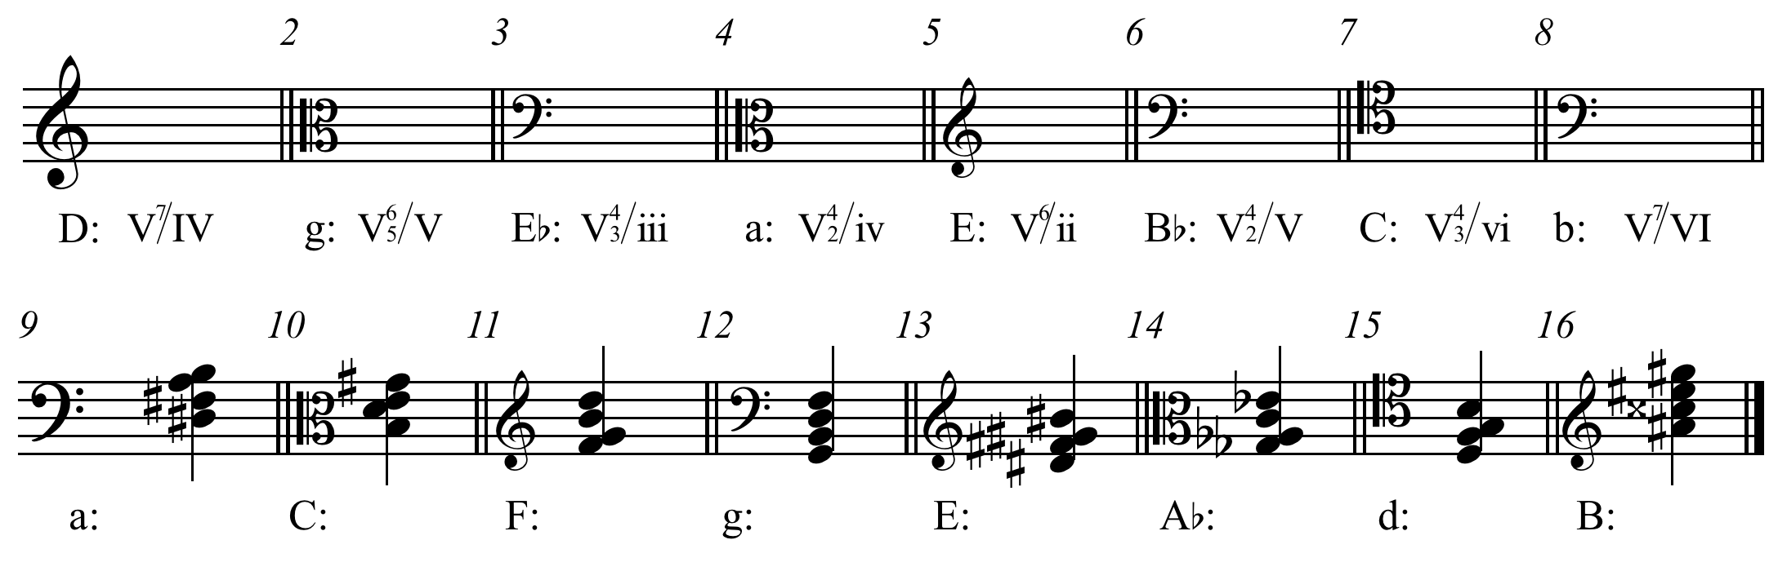

Write and Resolve

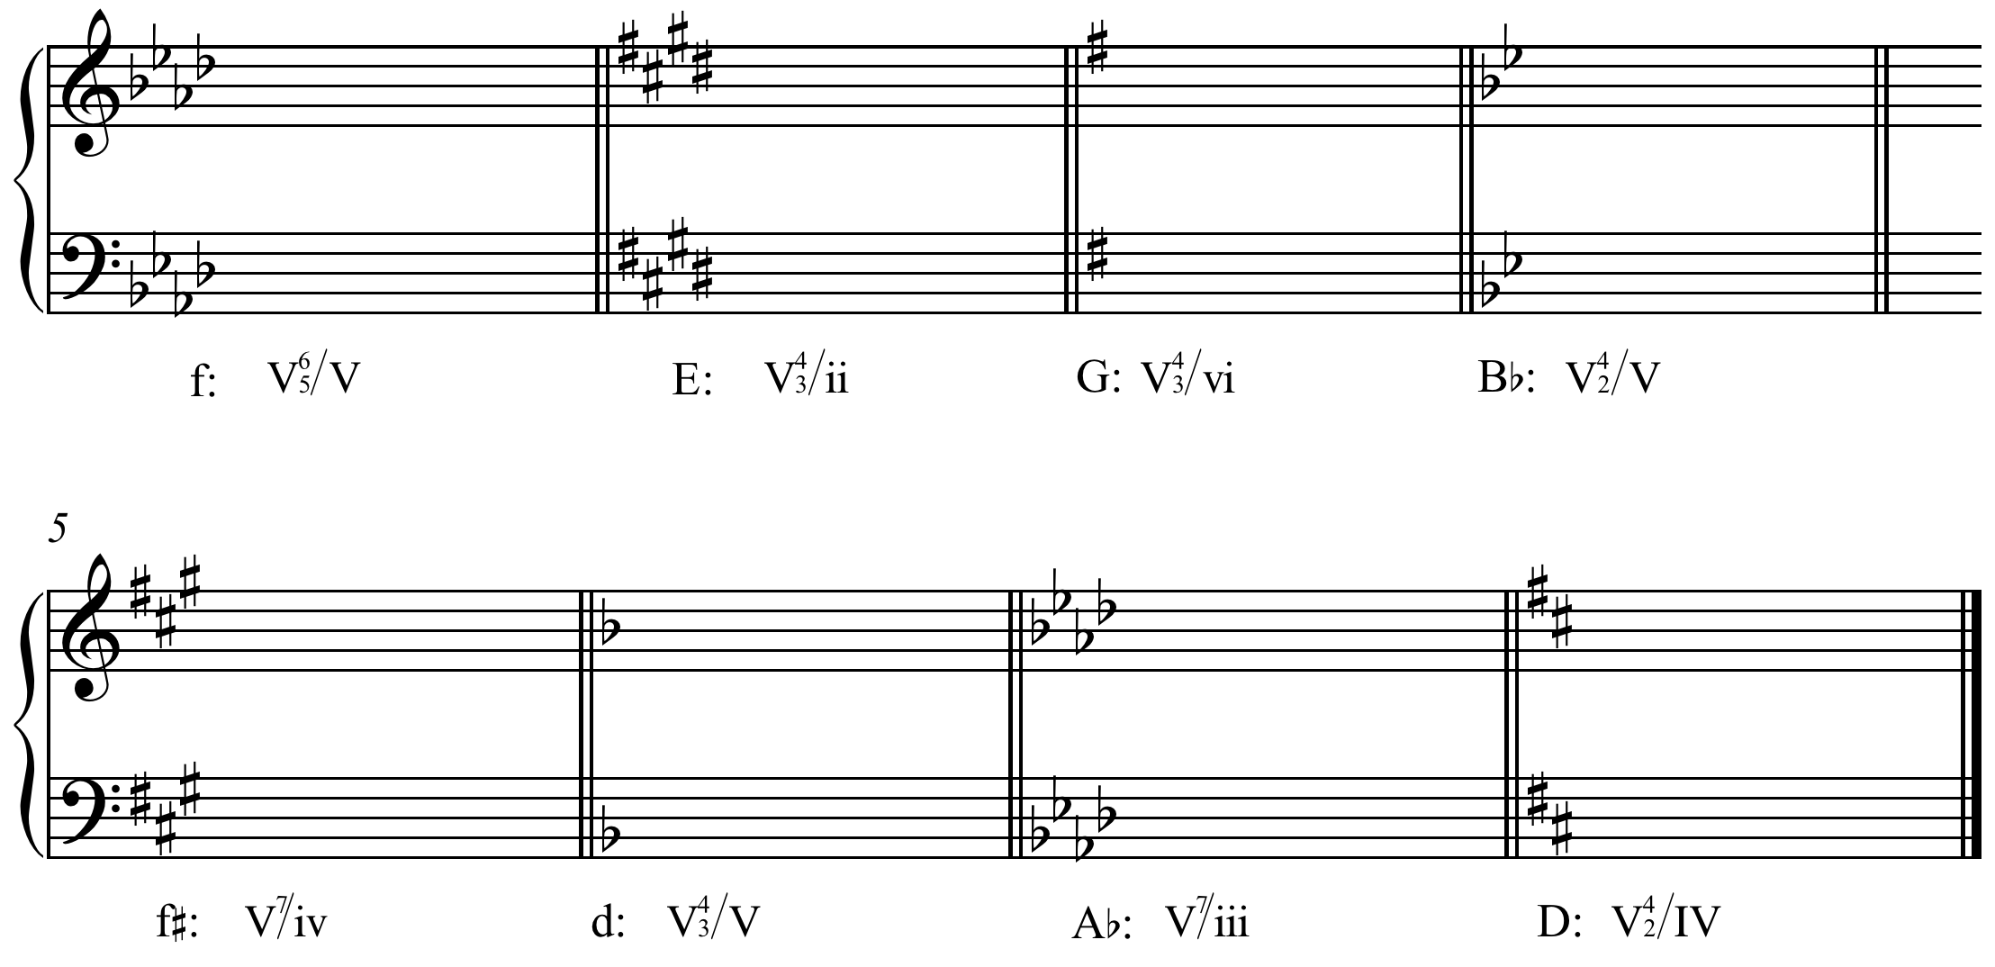

RN Analysis and write for SATB

