Intensive Part-Writing and Analysis

Assignment 10 Worksheet

**I.** With the bassline printed below, identify the key, write the RN's you would use to harmonize it, then write it for SATB. Use a cadential six-four chord, a root position dominant seventh chord and one of each of the inversions of the dominant seventh chord along with other appropriate chords (hint: you won't need the iii chord).

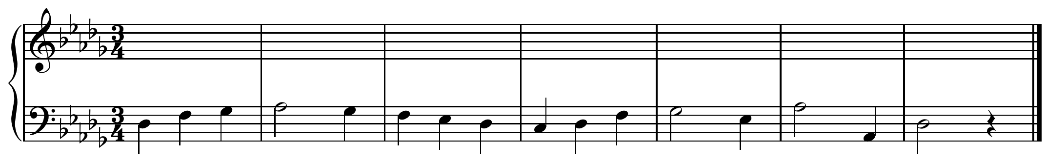

**II.** The following questions all pertain to Music Sources example 6.3 on page 37 (you'll probably need to photocopy that page to turn in).

* Listen to the piece several times, you'll find a link to it on the IPWA website.
* Here's a diagram of the large-scale form (ignoring repeats):

section: A B A' Codetta

measures: 1-8 9-16 17-24 25-27

**About the A section:**

1. It is a (circle one): parallel period contrasting period
2. The first phrase features what type of melodic contour?
3. The second phrase features what type of melodic contour?
4. On the score, indicate the key and do a RN analysis--be sure to indicate all inversions
5. The paired C5/Eb5 in the right hand (see m. 2 and 3) is used as nonchord tones at times. In m.2, circle the pair and label the type of NCT then do the same with the final beat of m. 3.

**About the B section:**

1. Its harmony largely features the alternation of what two chords? ___________ and ____________
2. It ends with a half cadence. Why do you think Kuhlau writes one there?
3. Circle and label a neighbor tone and a passing tones.
4. Write out a prominent rhythmic motive heard in the right hand:
5. Its melodic contour is more similar to that of which phrase from the A section?

**About the A' section:**

Why A' and not just A?

**About the last four bars or so:**

Why all the register changes? What does this do?

**Final Question:**

Compare and contrast the textures of the **A** and **B** sections.