Intensive Part-Writing and Analysis
Analysis Homework - due Sept. 20

The following questions all pertain to example 6.5 on page 39 of Music Sources. You can hear a recording of this excerpt through the Music Sources link on the IPWA website.

- Below is a phrase diagram of the excerpt. Indicate below the diagram the type of cadence that occurs at the end of each phrase.

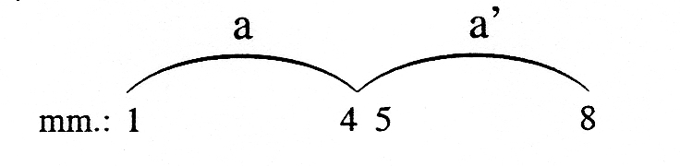

- Does this excerpt form a period? _________. If yes, then what type? ____________________ (see chap. 10 of K&P for details on phrase and period design)

- On the back of this page, describe the texture of this excerpt. Be sure to refer to the actual instruments seen and heard in the excerpt.

- Below is the harmonic rhythm (the rate of change of chord roots) for this passage. Indicate the key and do a Roman Numeral analysis, including inversions where applicable. See K&P pp. 135-137 concerning how to notate the cadential chords in ms. 4 and 8.

- Now, below your analysis, add a middleground harmonic analysis. This should show a tonic prolongation, pre-dominant, etc.

